ASSIGNMENT-DIGITAL MARKETING

|  |  |
| --- | --- |
| Reg No | 962820106306 |
| NM ID | 4A954CCB6901D2A8F4F43356767D6470 |
| Date | 20-10-2023 |

|  |  |  |
| --- | --- | --- |
|  |  |  |

1.Create a blog or website using Blogspot and WordPress. Customize the theme design and post new article with 500 words.

Link: https://jencika2002.blogspot.com/

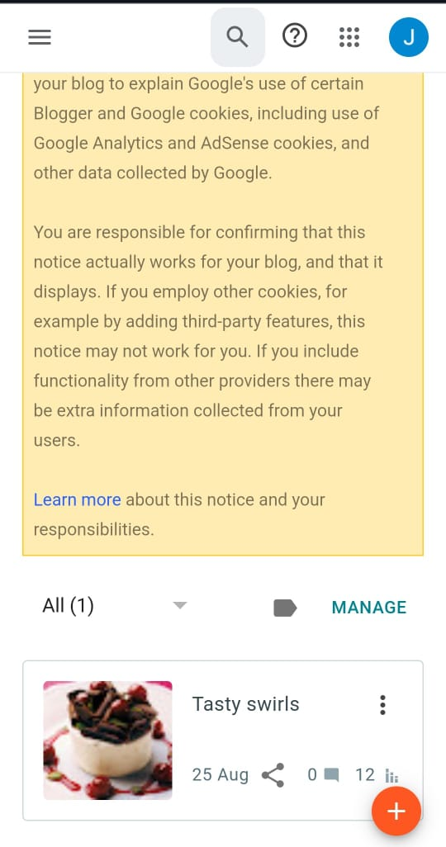

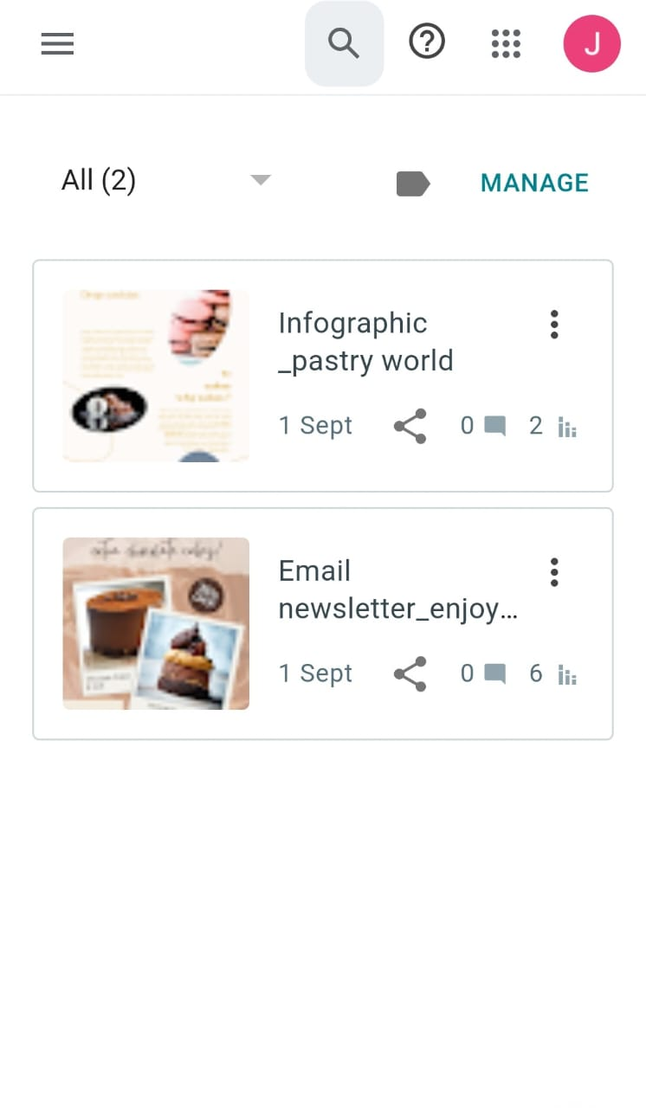

Link:https://jencika2002.blogspot.com/

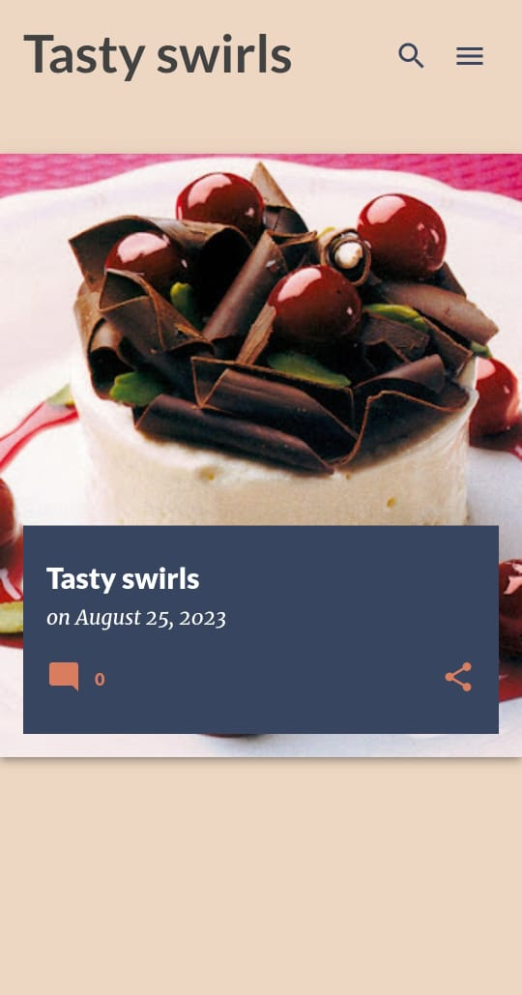

**2**.Create a new facebook page and post one social media poster for your brand.

Link:https://m.facebook.com/story.php?story_fbid=pfbid02d67FJofvZj2rH2hyQvTs4ALTHsTWg8sxps4s35AMvp5S5c8DHvZeZeLf3EhVia62l&id=61550069293344&sfnsn=mo&mibextid=9R9pXO

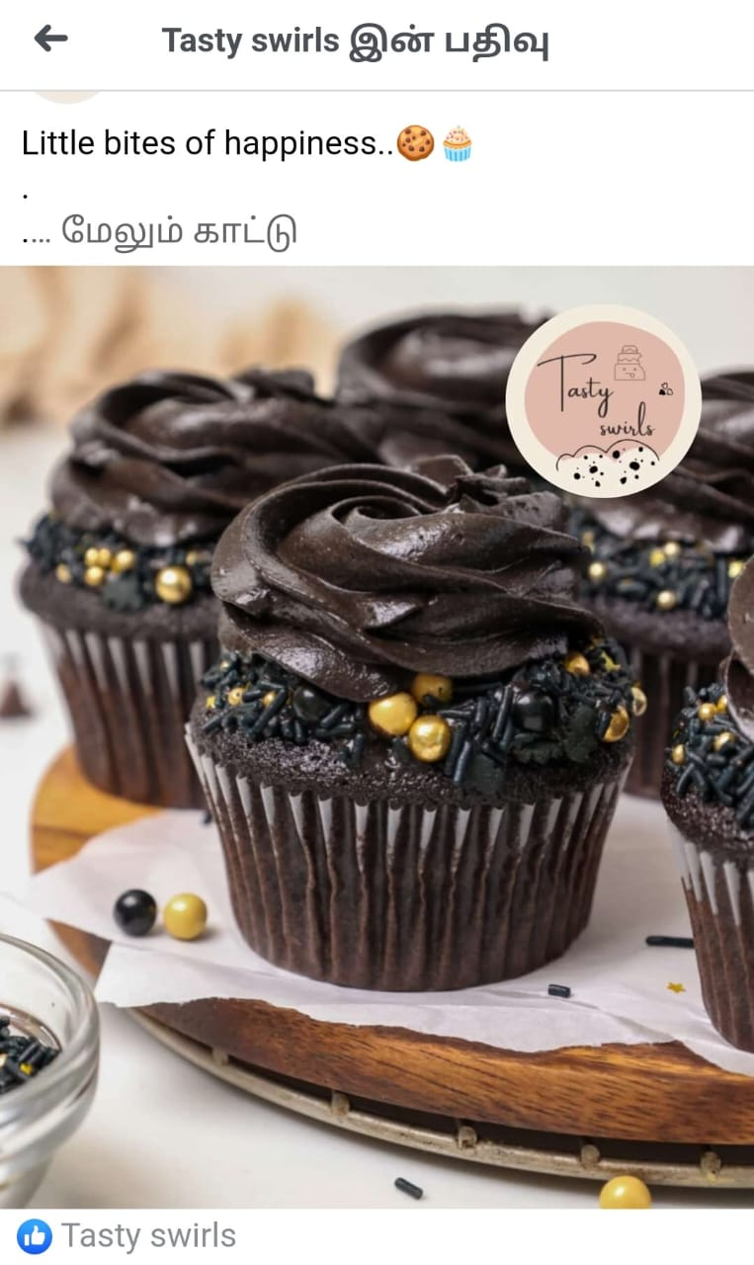

**3**.Create and design a social media advertisement poster using canva

Link:https://www.canva.com/design/DAFyDbctMXg/aZD5_fNHRzsGjKD3pc88vg/edit?utm_content=DAFyDbctMXg&utm_campaign=designshare&utm_medium=link2&utm_source=sharebutton

4.Create email newsletter design using MailChimp or canva tool.

Link: https://www.canva.com/design/DAFtL4DCX-s/O9LMVxMg0hbTj7W-RIuRJQ/edit?utm_content=DAFtL4DCX-s&utm_campaign=designshare&utm_medium=link2&utm_source=sharebutton

Link: https://jencika.blogspot.com/2023/09/email-newsletterenjoy-new-delicious.html?m=1